|  |  |  |  |  |  |
| --- | --- | --- | --- | --- | --- |
| Date | 9-Dec-22 | | | Tester Name | Janette Paus |
| Environment | Penfax - Test 2 | | | Login used |  |
| Operating System | Windows | Version: 21H2 | Update Number: | | |
| Software Used | Select Software | Version: 107.0.1418.56 | Update Number: | | |
| Select Software | Version: | Update Number: | | |
| Application Release version | R22.4.1 | | | | |
| Test Case Title | E20.12 | | | | |
| Test Type | Regression | | | | |
| Test Scenario | Reverse a Scheduled Withdrawal after Valuation | | | | |
| Expected Results | After a payment is processed to a member through a VPB scheduled withdrawal (monthly payroll has ran), reverse the payment. Ensure the funds go back into the member’s account the day they were withdrawn (not the day the reversal was processed) & that taxes (if any) are also reversed. | | | | |
| Pass/Fail | Pass | | | JIRA# |  |

Found an active VPB member with scheduled payment. To find this member I went to last month’s payment batch for the scheduled monthly payments and found a member:

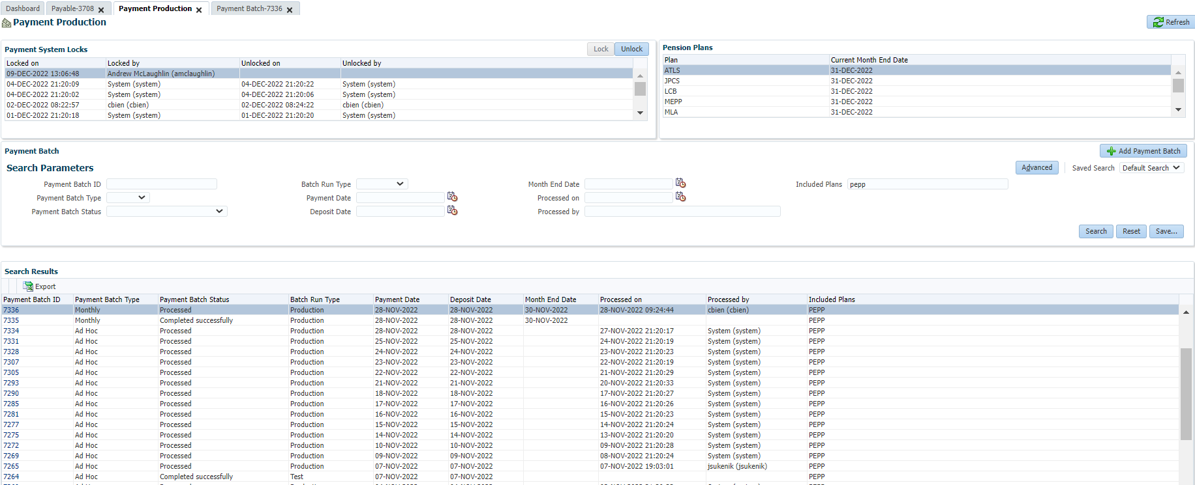

**SID – 238260**

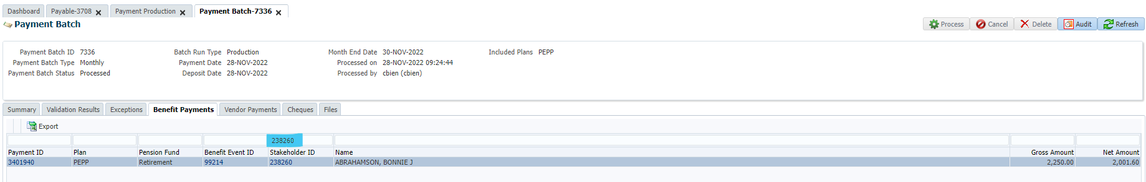

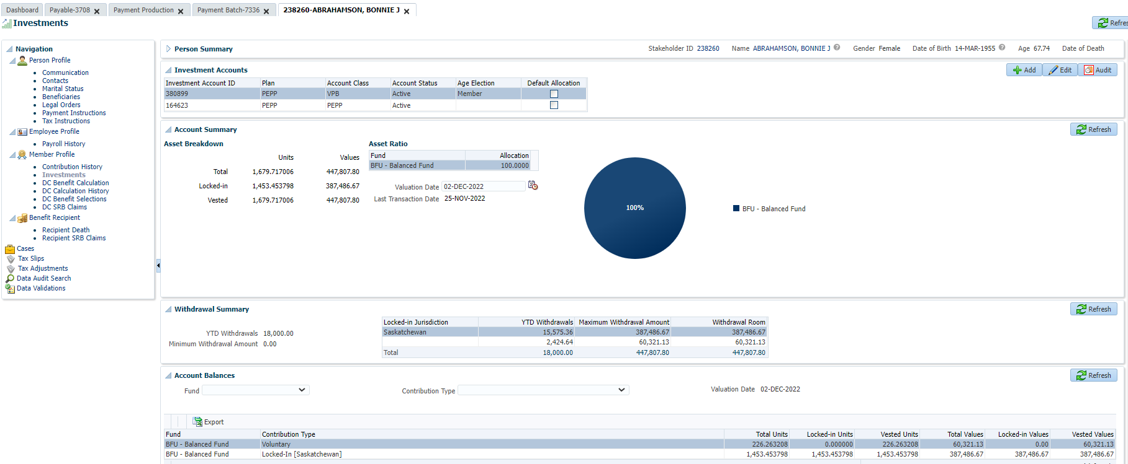

Suspend Benefit Recipient:

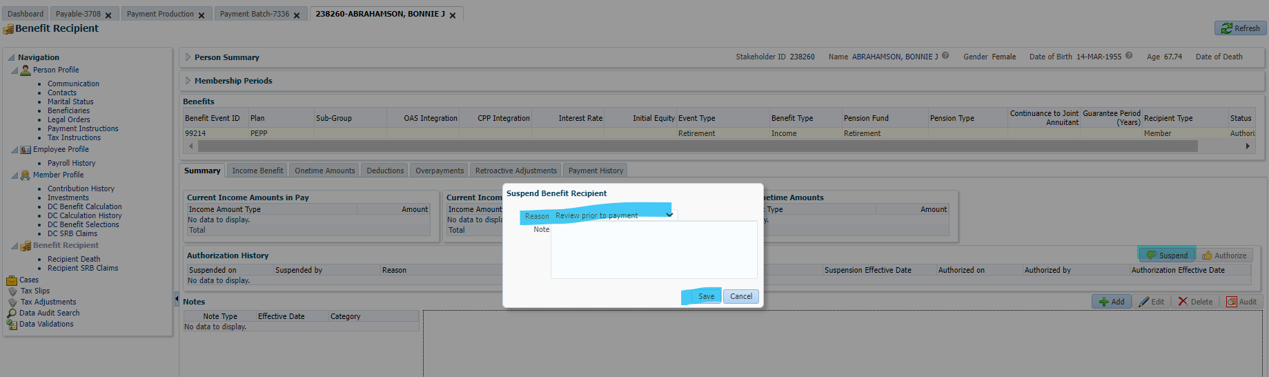

Click on payment history & the payment ID:

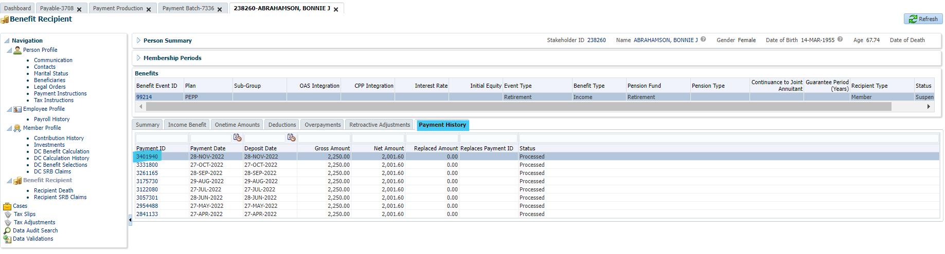

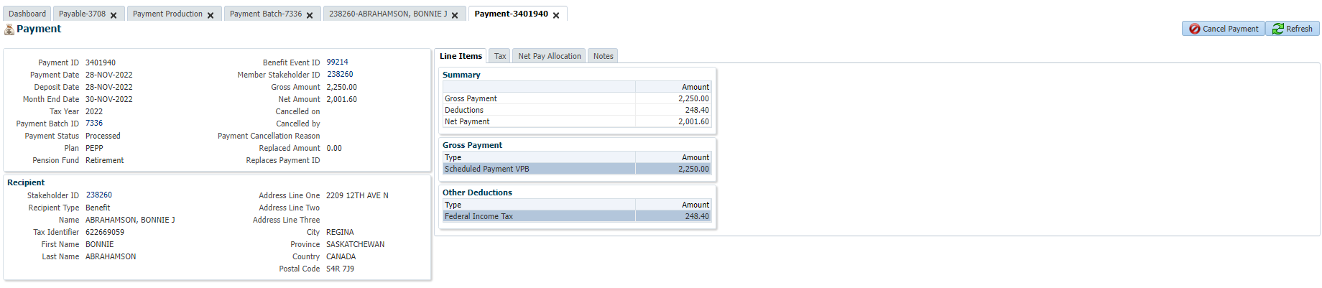

Then click cancel payment, select a reason & click Save:

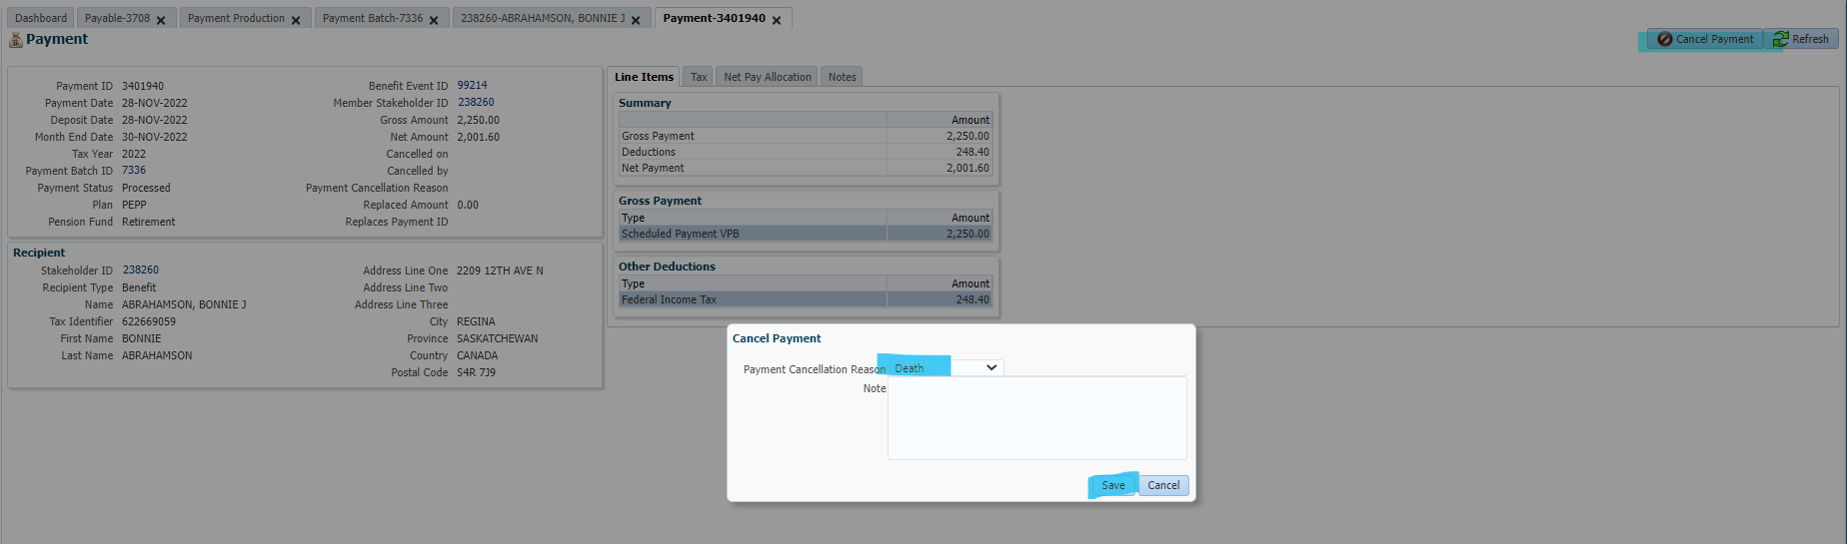

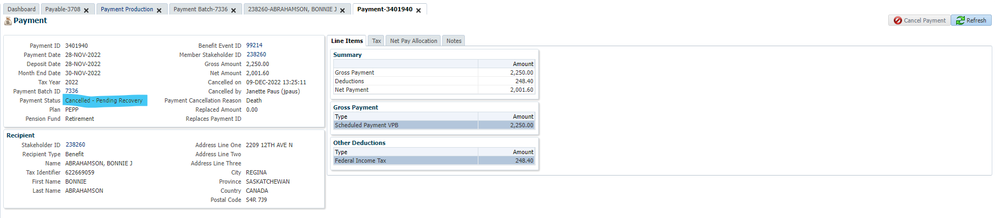

Click on the overpayments tab & click add in the row titled recoveries (Do this for each line in “line items:

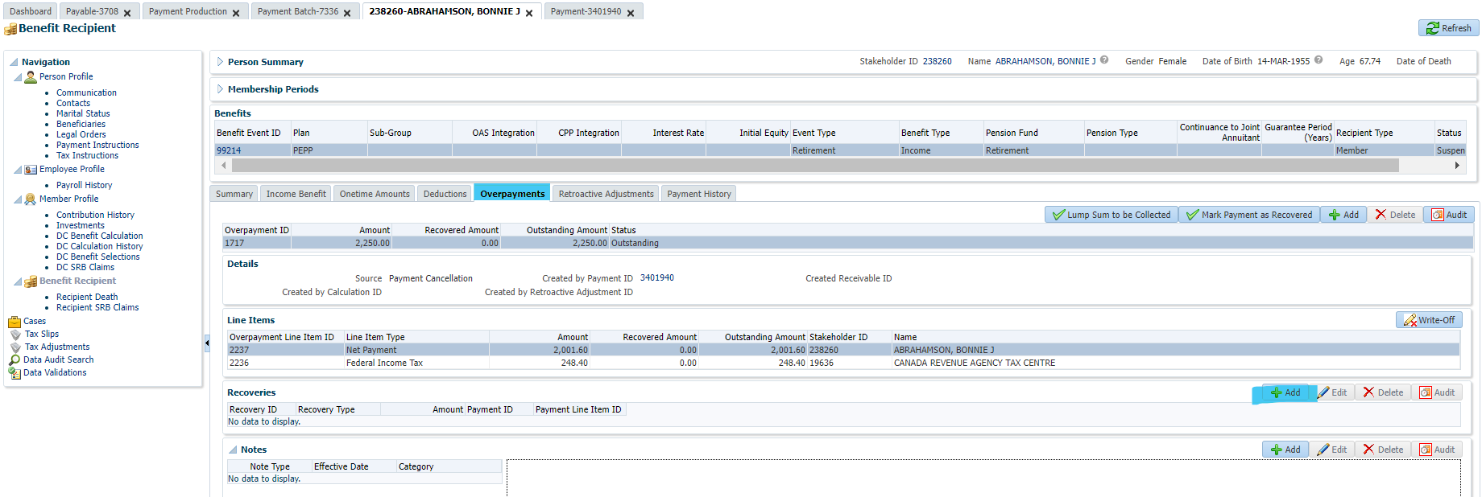

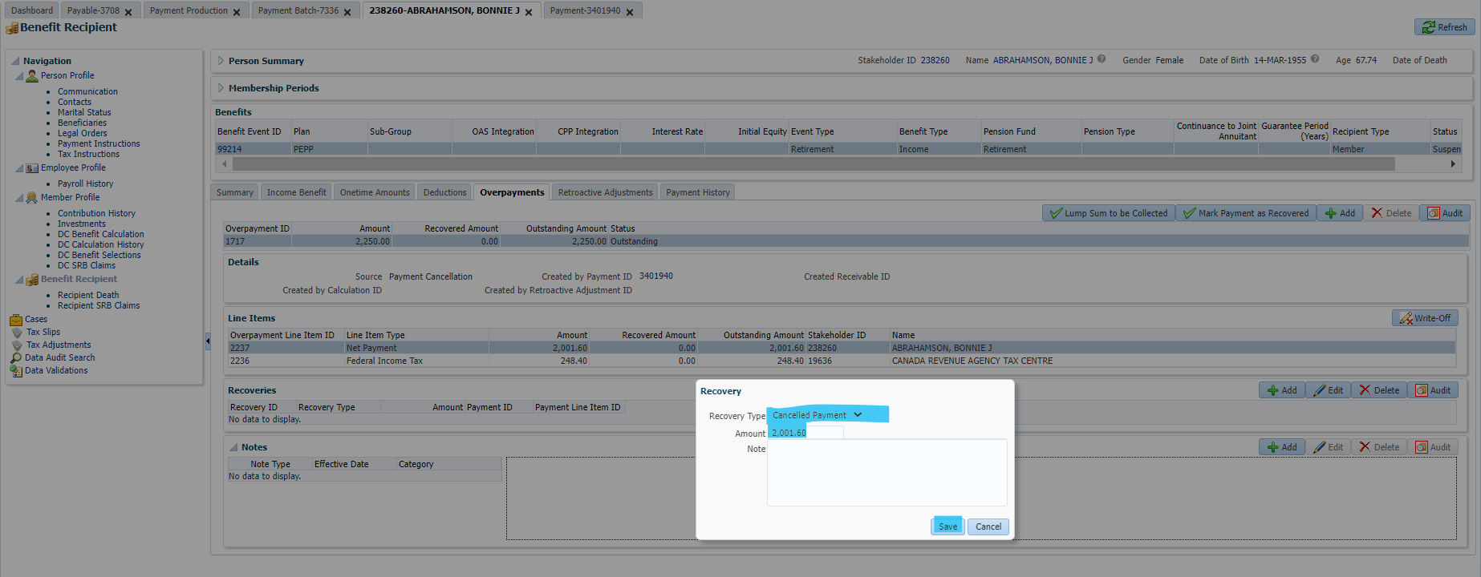

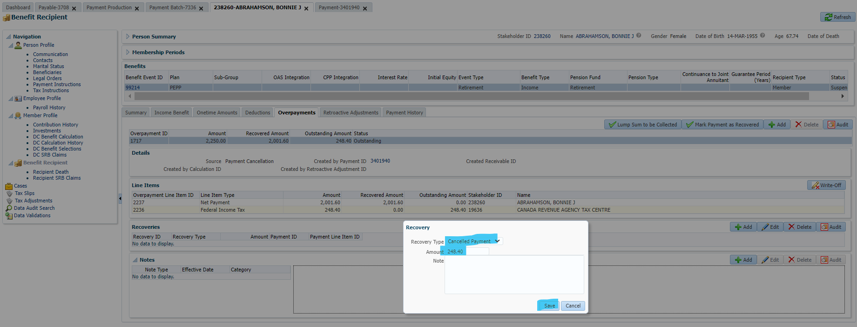

Click: Mark payment as recovered & save:

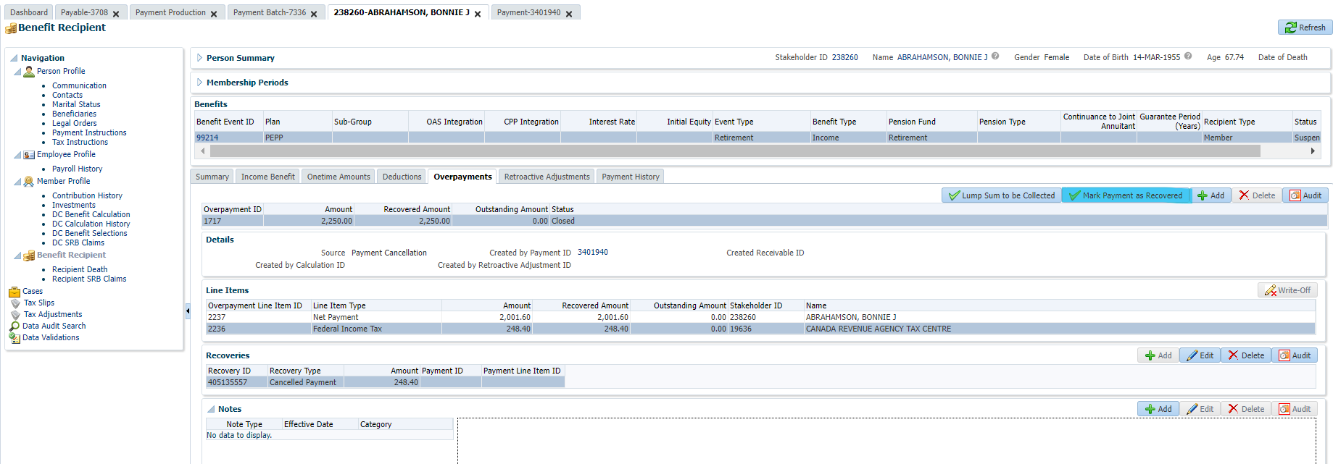

Notes carry forward from this screen to the person profile:

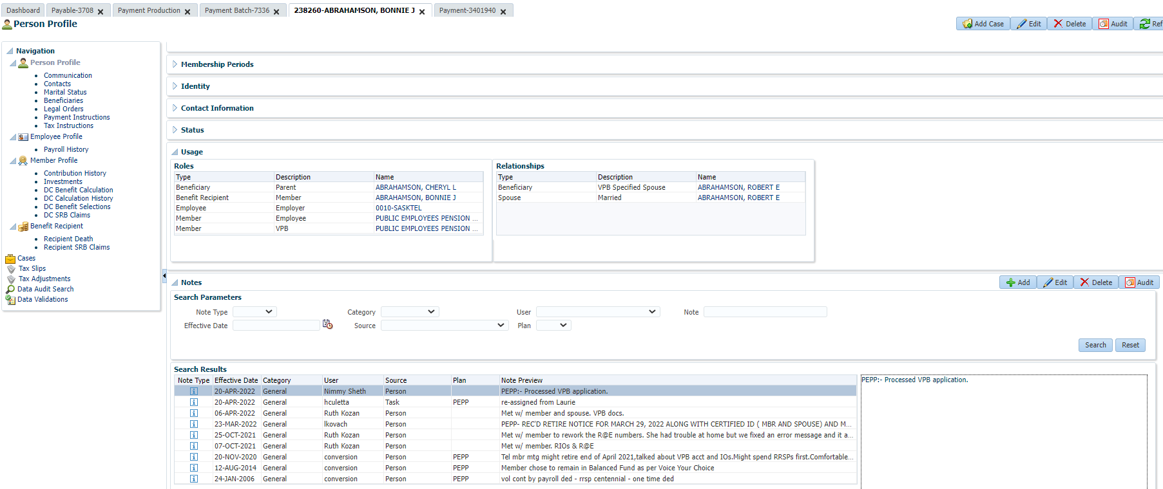

Benefit recipient shows as cancelled – Recovered:

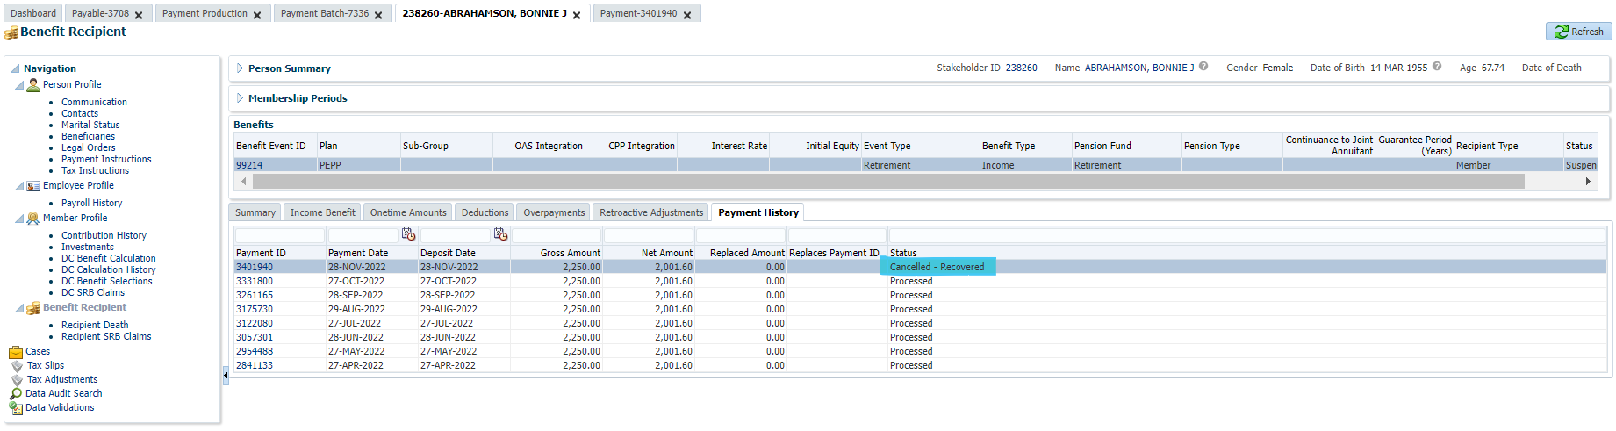

Reverse payment under investments/account activity:

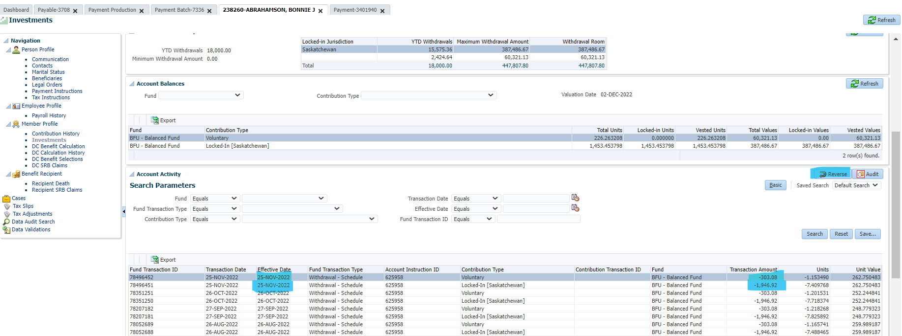

Click on each line of the November 25th withdrawal (both voluntary and locked in SK and click reverse):

Next Day— Sept 10

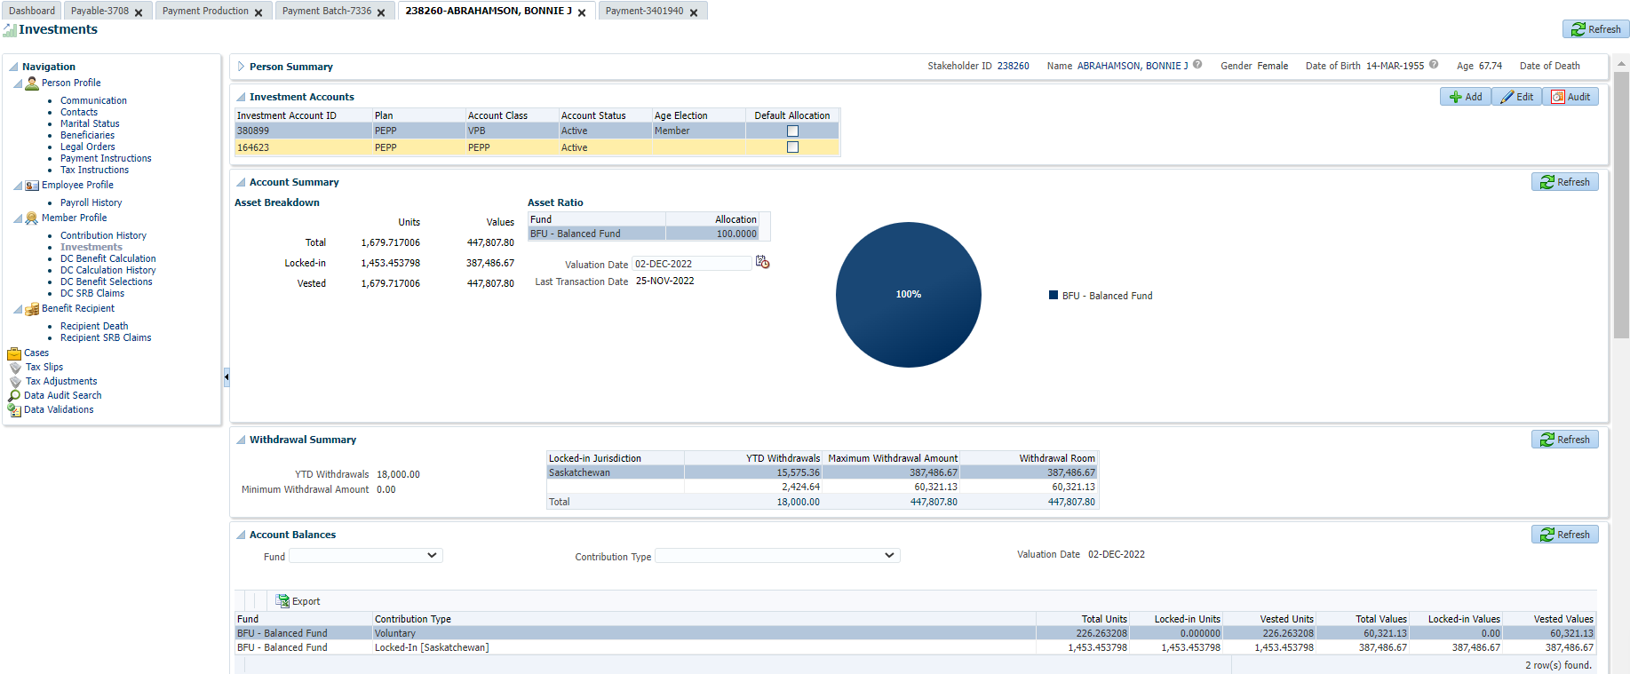

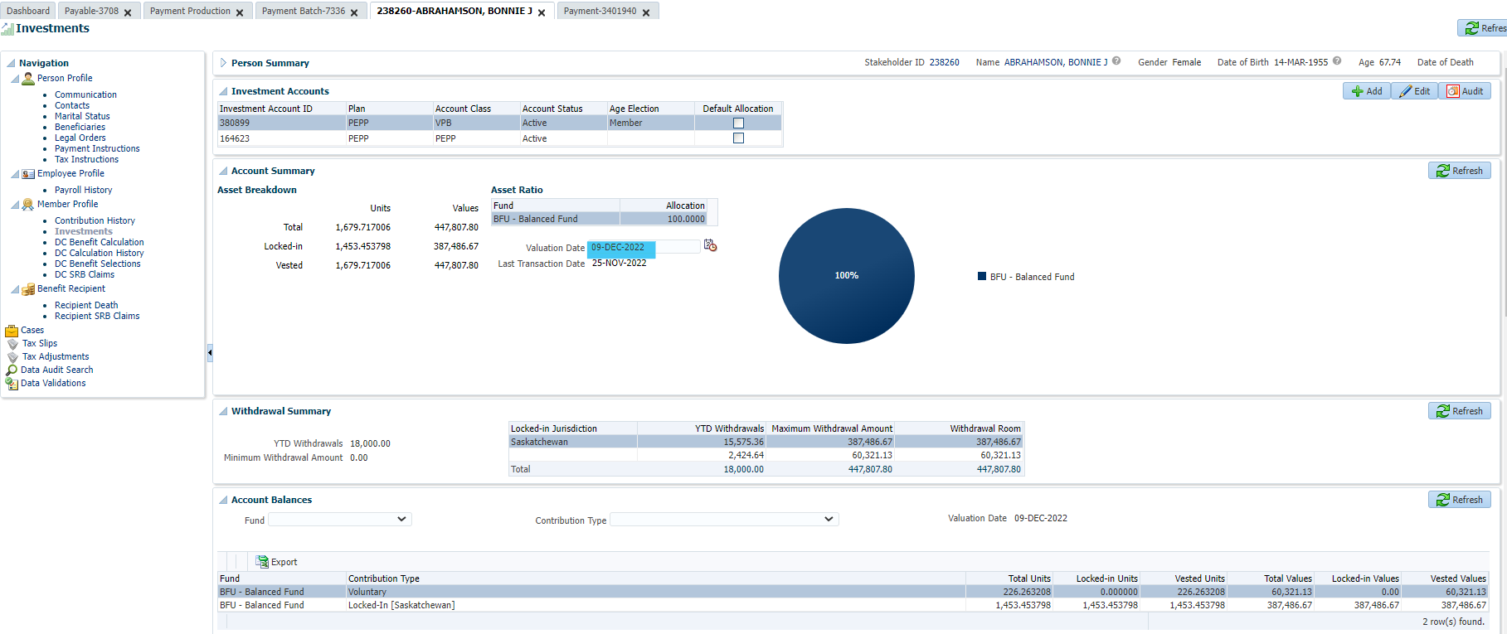

After PIT:

Confirmed units were added back into the account (compared to before reversal):

